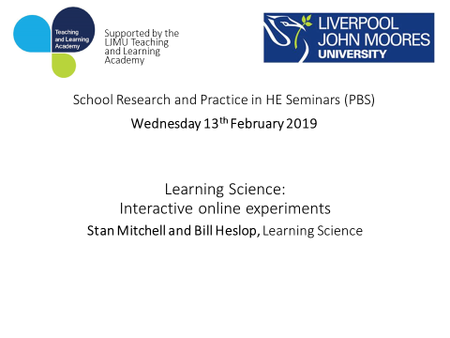

-----Original Appointment-----  
**From:** Denton, Philip   
**Sent:** 04 February 2019 14:44  
**When:** 13 February 2019 12:00-14:00 (UTC+00:00) Dublin, Edinburgh, Lisbon, London.  
**Where:** James Parsons Building Rm 302

**Invite sent on behalf of Janice Harland for the Faculty of Science**

Learning Science [www.learnsci.co.uk](https://hes32-ctp.trendmicro.com:443/wis/clicktime/v1/query?url=http%3a%2f%2fwww.learnsci.co.uk&umid=84805c24-ddeb-4d62-b2ab-5181513814ec&auth=768f192bba830b801fed4f40fb360f4d1374fa7c-ced3f33d3e61f664989251104baa6d66a8805b01) produce interactive online experiments in biosciences and chemistry that are ideal for pre-lab preparation and revision. Initial scoping indicates that these resources are impressive and would be a useful tool for our students. The Faculty of Science is supporting this event and funding lunch; please accept this invite by Friday 8th February if you are attending so that catering can be arranged. Responses to this invite are not individually monitored so please email [p.denton@ljmu.ac.uk](mailto:p.denton@ljmu.ac.uk) if you have dietary requirements. The demonstration will take less than an hour, leaving plenty of time for discussion.

Best wishes, Janie Harland (Programme Leader) and Phil Denton (Associate Dean, Education)

**Further information from Learning Science:**  
  
Our team is comprised of mainly PhD qualified scientists, instructional designers and software developers who are measurably improving student performance, engagement and satisfaction via pre- and post-lab solutions, particularly in the fields of chemistry and the bio-sciences. Our online offering is unique, combining an extensive library of a total of about 130 fully customisable and interactive simulations. These link with smart worksheets that deliver post lab assessments in a personalised, immediate and consistent format, providing richer feedback whilst dramatically reducing marking time.

You can view further samples of our pre lab online resources at: [https://www.learnsci.co.uk/resources/](https://hes32-ctp.trendmicro.com:443/wis/clicktime/v1/query?url=https%3a%2f%2fwww.learnsci.co.uk%2fresources%2f&umid=84805c24-ddeb-4d62-b2ab-5181513814ec&auth=768f192bba830b801fed4f40fb360f4d1374fa7c-4897c3323203ecbfde3a16e222389b05180146de)

We offer an annual licence which is extremely cost-effective and provides several benefits to the university:

* You would have access both to all existing simulations and new simulations as they become live, across the university and to an unlimited extent.
* We have an in-house team of highly qualified scientists and development specialists (mostly PhD qualified) who are constantly working on new resources.
* The new resources are developed directly as a result of collaboration with our existing university partners: You would become a contributor to this process.
* These simulations are fully customisable, enabling our specialists to tailor them to your actual laboratory experiments.
* All of this makes the offering unique and numerous leading universities have now adopted these resources, including, for instance, Oxford and Cambridge.
* It embeds seamlessly into your VLE and will function on any device, affording your students the opportunity to practice before even entering the laboratory.
* Surveys on our website confirm that students confidence, engagement and performance levels all improve as a direct result of accessing these simulations.
* Valuable laboratory time is saved as the tutor is no longer called upon to answer elementary questions from students.

Here is a link to a case study that we recently published: [case study article about our partnership with Coventry University's School of Life Sciences](https://hes32-ctp.trendmicro.com:443/wis/clicktime/v1/query?url=https%3a%2f%2fwww.learnsci.co.uk%2fblog%2f2018%2f3%2f1%2flearning%2dscience%2dcase%2dstudy%2duniversity%2dof%2dcoventry%2dbiosciences&umid=84805c24-ddeb-4d62-b2ab-5181513814ec&auth=768f192bba830b801fed4f40fb360f4d1374fa7c-c6c7073f923ce1001affc22e5db0b6336c445fd2)

Our post lab smart worksheets can be viewed at: [https://www.learnsci.co.uk/post-labs/](https://hes32-ctp.trendmicro.com:443/wis/clicktime/v1/query?url=https%3a%2f%2fwww.learnsci.co.uk%2fpost%2dlabs%2f&umid=84805c24-ddeb-4d62-b2ab-5181513814ec&auth=768f192bba830b801fed4f40fb360f4d1374fa7c-5274414febefe273a4502d14c041018a6ead5a81)  These 'Smart Worksheets' are developed on a bespoke basis in collaboration with you meaning that your tutors decide exactly what they want them to achieve.

We visited some 35 universities last year alone and everyone expressed genuine interest and appreciation for the presentation, indeed most of them have now adopted our resource library, including for instance Oxford, Cambridge and more than half the Russell Group.