**Faculty of Science**

**How Do I Do That?**

**Rough guide to Marybone, Cherie Booth**

**and Upper Peter Jost AV**

**Updated 30/9/2018**

# Acknowledgment: Thanks to the Byrom St AV technicians for demonstrating the new AV systems within Marybone.

# 1 Introduction

During the summer of 2018, these three lecture theatres were completely refurbished and have new AV and lighting systems. The AV set-ups are sufficiently similar to be covered in the same guide. For example, all rooms have two data projectors that cast onto two main screens with repeater monitors.

## Marybone

The new theatre has a new central aisle and a central podium. The front row is closer to the screen than previously. Planned capacity = 357, Appendix 1.

## Cherie Booth

This has changed radically and the orientation of the room has been rotated by 90o to create a ‘Harvard’/in-the-round style lecture space. There is no central podium, and AV can be accessed at the side of the room. You are strongly advised to use a [presenter controller](http://wowie.ljmu.ac.uk/FacultyLTA/goodpracticesharing/PowerPoint%20controllers.htm) in this space, although the wireless mouse can be used as a workaround. Planned capacity = 144, Appendix 2.

## Peter Jost

This now has fixed work surfaces and the stage has been removed and replaced with a central podium. Planned capacity = 110, Appendix 3.

# 2 Audio

All theatres have podium, [handheld and radio microphones](https://www.youtube.com/watch?v=JIwBCX8j-UQ), the former being referred to as the ‘lectern mic.’ Only the podium microphone volume can be controlled by the AV control panel (overleaf). The mobile microphones have a pre-set volume and will connect/work automatically ~15 seconds after removal from the charging caddy on the podium. There should be no need to press any buttons on these devices before they work.

The in-built microphones are configured to work with both Panopto and the PA system. Within Panopto, select the audio stream that captures their sound (as indicated by the green-red sound bar).

As a default, the volume of attached devices is muted at the start of a new session and this can be changed by pressing the mute button. This should prevent any noisy surprises!

# 3 Lighting

All theatres have pre-programmed settings, the Marybone controls being distinct.

## Marybone

Lighting can be controlled from the AV control panel or by the switches by the door. Both appear to be pre-programmed with four levels (including ‘off’), although the switch by the door enables dimming up or down from these settings.

|  |  |
| --- | --- |
| **Cherie Booth/Upper Peter Jost** |  |
| Lighting is controlled by a separate box on the podium and this has five settings. Setting 2 appears to be optimal for lecturing as it turns off those down-lighters next to the screen while illuminating the remainder of the room.  **4 AV Control panel**  This has an appearance similar to the previous set-up and is intuitive to a degree. |

Mute button

‘Currently displaying’ buttons (left and right main screens)

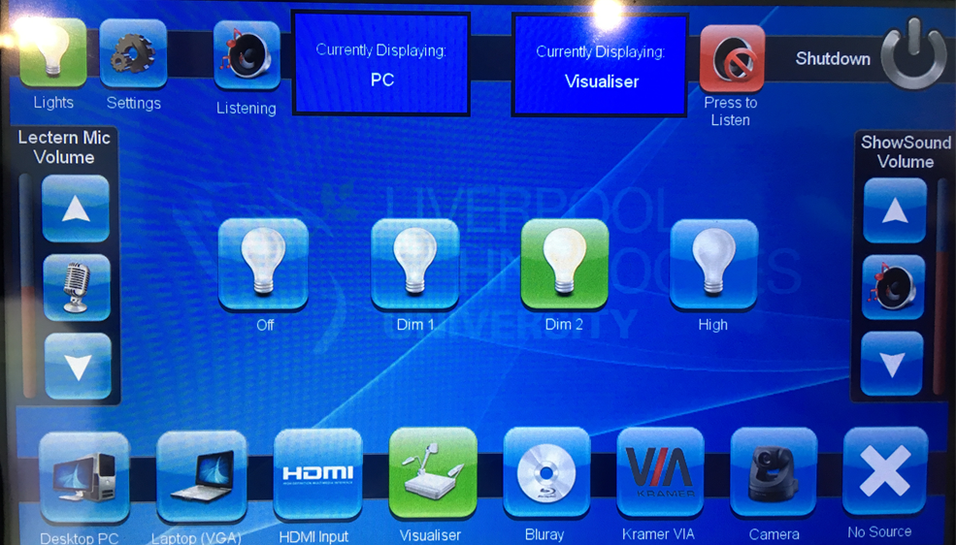

Source volume

Podium mic volume

After selecting a source from the list at the bottom, you must select the left and right ‘currently displaying’ buttons to show that source on the left and right main screens.

This means you can show different sources on each screen, as in the example set-up in the image above: PC (left screen) and visualiser (Right screen).

To ‘pic mute’ on both main screens, therefore, you would need to press ‘No Source’ and then press both the left and right ‘currently displaying’ buttons.

‘Settings’ allows you to control what is shown on the repeater monitors – this can be the same or different to the main two projector screens. You may want to explore this functionality outside of ‘live’ teaching.

The camera source is a ceiling-mounted camera pointing at the podium. The panel can be used to control the degree of zoom. At the time of writing, Panopto did not detect this camera as a video source in Marybone.

**5 Connecting laptops**

All rooms have HDMI and VGA connectivity, although Upper Peter Jost is distinct in how this is presented. In all theatres, select source = VGA or HDMI.

## Marybone/Cherie Booth

HDMI and VGA cables are built in to the podium for connection to your device.

**Upper Peter Jost**

There are two ports on the podium, next to the AV control panel and these did not have cables attached at the time of writing.

Phil Denton

Associate Dean (Education)

21/9/18

# Appendix 1 Marybone floor plan

The red boxes are the video projectors and the six blue lines represent the repeater monitors.

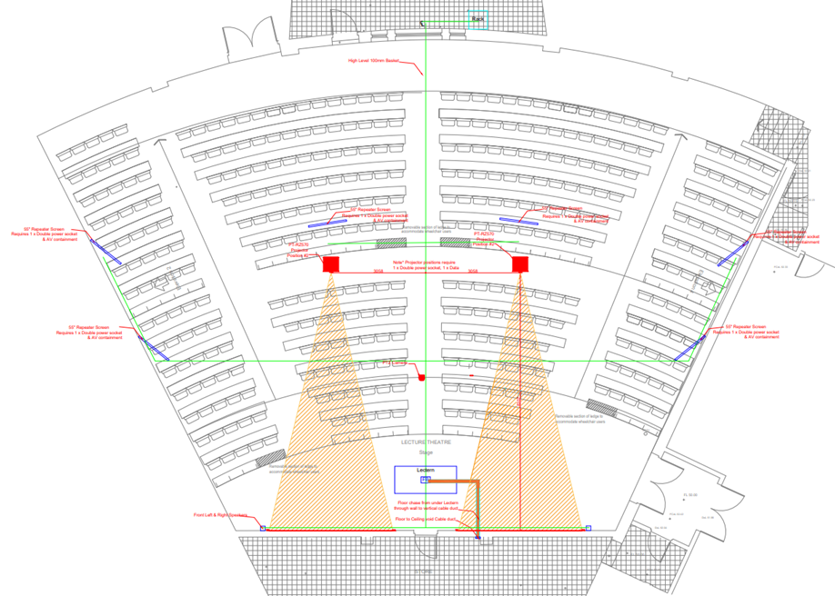

# Appendix 2 Cherie Booth Floor Plan

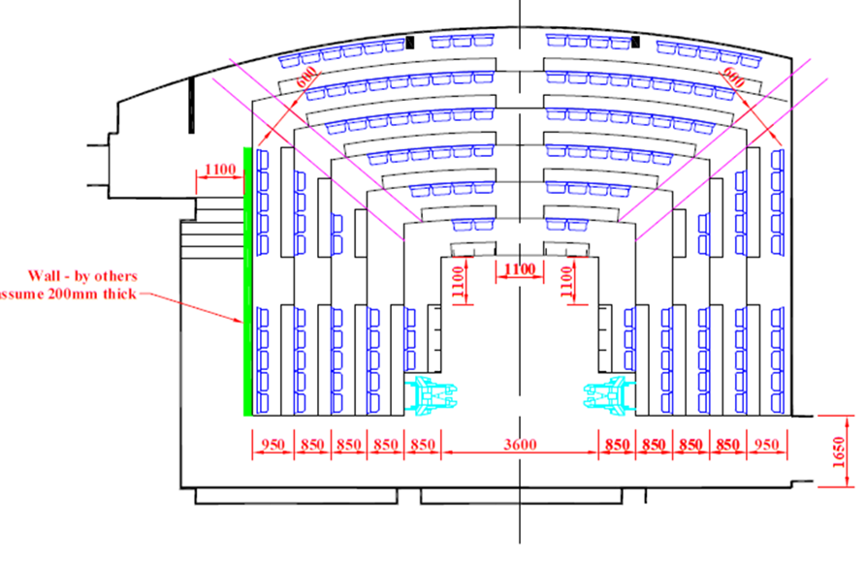

# Appendix 3 Upper Peter Jost Lecture Theatre

The central podium is not shown in this diagram.

