  Faculty of Science | School of Biological & Environmental Sciences EDI Coordinator Annual Report 2020/21  Author: Nicola Koyama  Date: 31 May 2022

Introduction
This is the second BES EDI Annual Report and summarises activity since submission of the last report in June 2021. Broad objectives identified in the 2020/21 Report were to
- Complete and reflect on the BES Decolonising The Curriculum audit with the aim to maintain and develop activities and to take steps to foster an inclusive culture. COMPLETED
  - First DTC audit was completed (July 2021) with delivery of planned content in 2021/22, inclusion of DTC in Periodic Programme Reviews (PPR), dissemination of good practice within and outside the university and second DTC audit completed (May 2022) with School discussion, reflection and 2022/23 planning meeting (scheduled June 2022). See below for detail.
- Complete the BES Athena Swan Submission. COMPLETED
  - The BES Athena Swan application for Bronze Award was developed by the Self-Assessment Team (SAT), and submitted in March 2022. A successful result was received in May 2022, with the Bronze Award conferred for five years until 31 May 2027. See below for further detail on developments and initiatives in 2021/22.
- Develop a School outreach strategy to support recruitment of under-represented groups. COMPLETED
  - A second Public Engagement Coordinator (including external engagement and outreach) was appointed in January 2022. The EDI Coordinator fed back on the draft BES Public Engagement Strategy 2022 to ensure it aligned with the current LJMU Access & Participation Plan recruitment targets for underrepresented groups, and the document was approved at the School Management Team (SMT) meeting in March 2022.
The BES School EDI Group continued to meet during 2021-22, alongside the Athena Swan Self-Assessment Team (SAT), and A BES EDI Objectives & Action Plan document was created (Summer 2021) to facilitate and disseminate progress (all actions completed). Any new 2021/22 BES matters arising and ongoing actions were incorporated into the BES Athena Swan Action Plan, as the two groups will merge following submission of the Athena Swan application.
In addition to the Faculty of Science EDI Panel and to coordinate with activity across the university, the EDI Coordinator sits on: Attainment Gap Council, APP Working Group, Institutional Athena Swan Working Group, Respect Always Steering Group and Chairs the Decolonising the Curriculum Working Group.
This report will consider developments under two sections: A. Decolonising the Curriculum and an Inclusive Environment (The BES EDI Coordinator and BES EDI Group) and B. The BES Athena Swan Application (SAT), with ongoing and new actions in blue font.

A. Decolonising the Curriculum and an Inclusive Environment
The BES EDI Coordinator and BES EDI Group

Decolonising the curriculum

Following the audit of current and planned activity in 2020/21 (including support provision from the EDI Coordinator of a sharepoint of 100+ subject-specific articles, a six-part seminar series, a bespoke audit template, and one-to-one support), activity this year by the EDI Coordinator has included
- Further one-to-one support for staff to develop module and programme content
- Revision of detailed 'anonymous marking in Canvas guidance' document created in 2020/21, reminders sent to staff about our anonymous marking policy (September 2021), and to students about what and why we mark anonymously and to remember not to write their names on assignments (October 2021)
- Discussion and dissemination of good practice within LJMU to guide progress in BES during
  - Teaching & Learning Academy workshop (November 2021)
  - Academic Registry presentations in (Jul, Oct and Nov 2021, Jan and Feb 2022) at PPR Development Sessions, PPR panel workshops, Collaborative Partnership Forum
  - Presentation and discussion with the Astrophysics Research Institute (Oct 2021)
  - PGCert presentation (February 2022) Teaching & Learning Academy
  - Doctoral Academy presentation (February 2022) on approaches to decolonising research for PGRs
  - Students at the Heart Conference 2022, presentation and workshop
- Programme teams have been able to use last year’s detailed audit template to evidence progress towards decolonising the curriculum within Periodic Programme Reviews leading to
  - inclusion of programme learning outcomes in 2021/22 Periodic Programme Reviews specifying student understanding of a decolonial perspective for some programmes
  - compulsory tutorial attendance for some programmes, ensuring engagement with DTC content
  - commendations of good practice by PPR Panels for two undergraduate programmes
- A second audit of delivery of DTC content in 2021/22 within all modules for all undergraduate and taught postgraduate programmes was organised by the EDI Coordinator (May 2022)
- Evaluation of DTC delivery will take place during a BES workshop in June 2022 to facilitate much needed coordination of content between levels and programmes to ensure efficient delivery. Further action planning as needed
The EDI Coordinator has also been active externally, presenting DTC talks and attending DTC workshops to discuss approaches and progress towards DTC in STEM. This has been invaluable in understanding national and international directions to inform developments within BES
- Attended eight STEM DTC workshops run by (Advance HE, QAA, Pearn Kandola and the universities of Birmingham, Bristol, Leeds, Kent, Keele and Nottingham Trent)
- Presentations to Life Sciences, University of Sussex (April 2022) and forthcoming Universities and Professional Bodies Working in Partnership to Decolonise the STEM Curriculum organised by Heads of University Biosciences (July 2022).
- Discussions with Royal Society of Biology and invitation to future working group on decolonising the curriculum.

Inclusive environment

Creation of new BES EDI Induction Pack
The EDI Coordinator created a comprehensive EDI Induction pack presented at Induction talks and uploaded to Canvas programme pages, containing
- Programme year group induction talk slides (what is EDI, where to get support, how to report an incident)
- A 10min video recording from the EDI Coordinator about equality and equity, privilege, and useful EDI contacts
- A series of infographics (edited and revised from the DTC Curriculum Enhancement Internship) on the “Equality Act”, “Awarding Gaps” and “Decolonising the Curriculum” (Fig. 1).
- An infosheet about the BES EDI Coordinator, contacts, where to get support and how to get involved
- Enrolment instructions for LJMU Canvas EDI Course, now mandatory for students (either embedded in a Semester 1 module or advertised at Induction with evaluation of uptake at the end of 2021/22. Action: A survey by the EDI Coordinator (May 2022) found that Programme Leaders are not able to monitor uptake unless embedded within a module. Present data to School Director and recommend integration into a Semester 1 module for all programmes/levels in 2022/23.
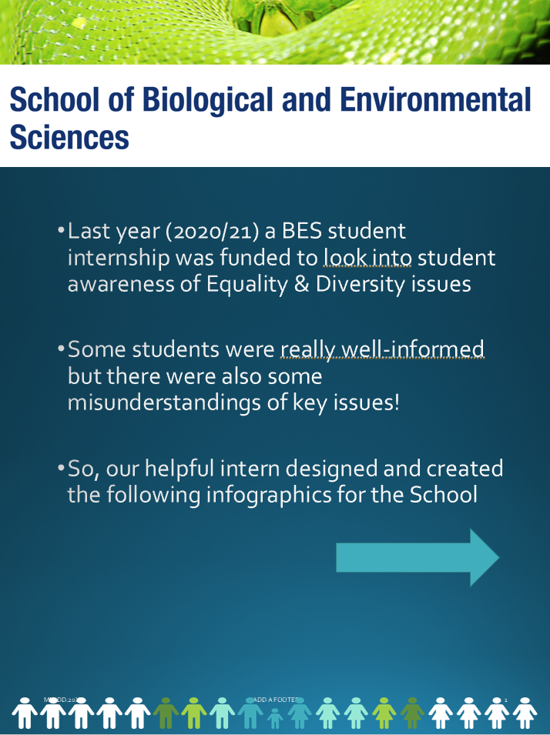 | 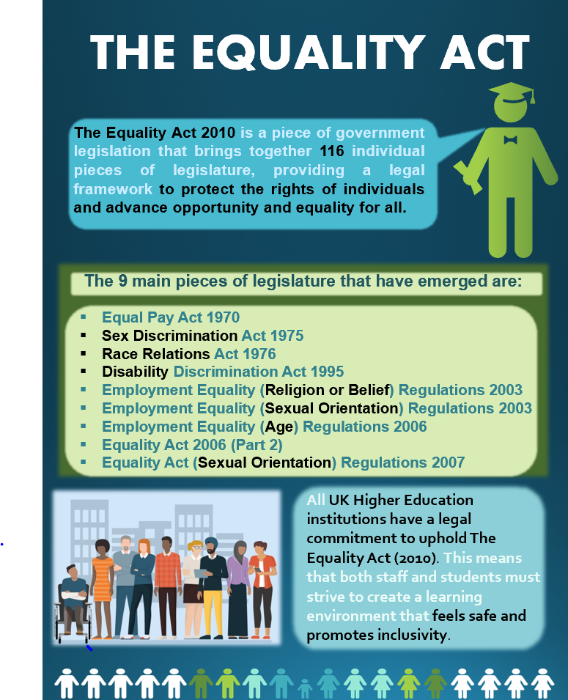 | 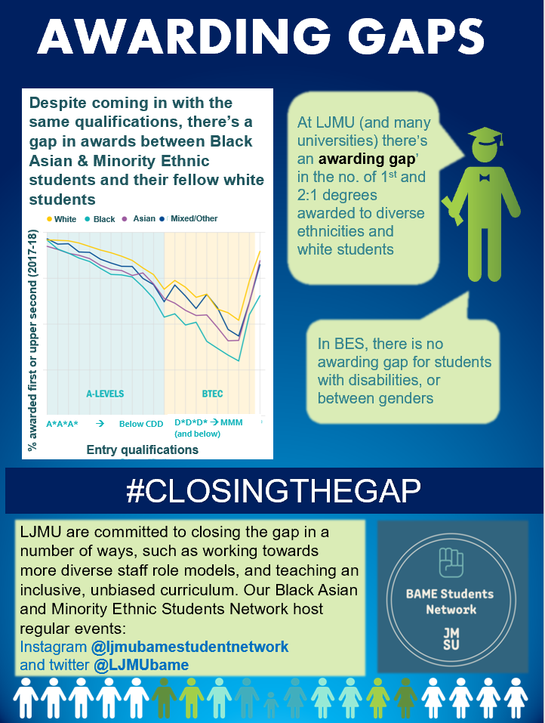 | 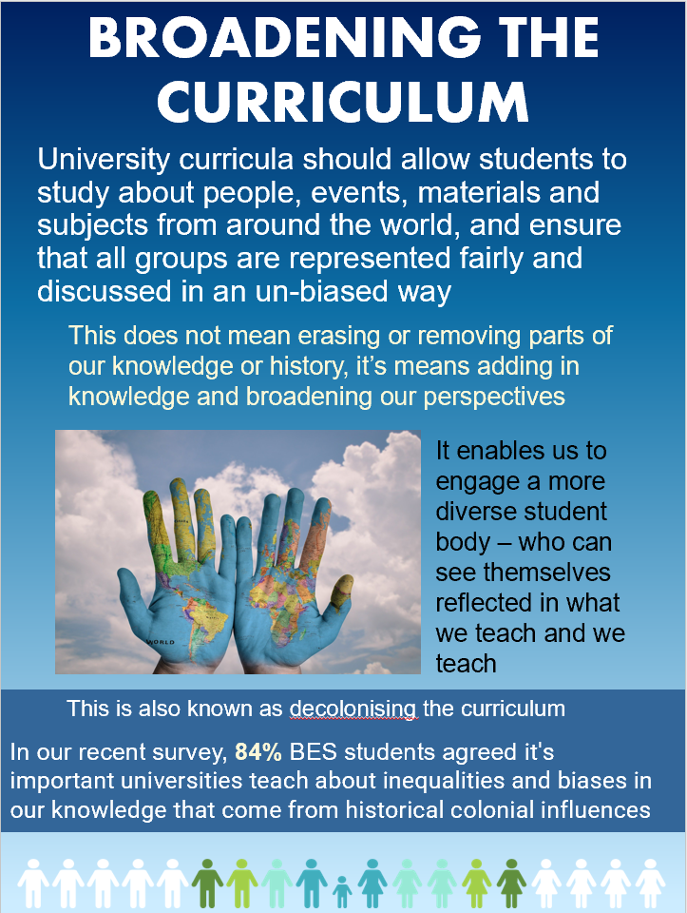
Figure 1. BES EDI Infographic series created for and circulated at student induction (L3-7)
Staff EDI update (October 2021): Staff presentation by the EDI Coordinator shared
- The 2021/22 BES EDI Objectives & Action Plan
- Detailed results of 2021 Student Harassment Survey (10% BES Students witness or experience harassment)
- Result of DTC survey (84% students agreed universities should teach about inequalities and biases in our knowledge that stem from historical colonial influence)
- Update on BES DTC progress and 2021/22 aims
- Update on BES Athena Swan progress
- Highlight Student EDI Induction pack prepared by EDI Coordinator
- Update on LJMU EDI news

Circulation of the BES EDI Comments Form (anonymous option)
- For students at Induction meetings and on Programme Canvas pages
- For staff at the EDI Coordinator’s talk during the Staff Forum in October 2021
- Feedback indicates these forms are not easy to locate. Action: To situate links to these forms on the BES EDI webpage (ongoing)
Discussion and dissemination of Student EDI issues throughout year:
- In October 2020, EDI was added as a standing agenda item to all Programme Team Meetings and Boards of Study within BES, with BES EDI group members (representing all programmes) providing EDI updates at Programme Team Meetings.
- This was reviewed by the EDI Coordinator in October 2021, finding effective EDI dissemination within programme teams, but little programme reporting or discussion at Boards of Study (it is not feasible for the EDI Coordinator to attend all BSc and MSc Boards of Study).
- The EDI Coordinator introduced a semesterly BES Student EDI Issues and Action Report to be presented at Boards of Study, in person or by the Chair (January 2022).

Campaigning against direct discrimination of transgender students by LJMU processes and support for non-binary students
- One-to-one support for BES trans students requesting name changes
- Requested details of name change process for transgender students from Registry (August 2021) and highlighted shortcomings in procedures leading to direct discrimination and lack of transparency of information
- After no action above, exchanged many emails and organised several meetings with EDI Team, Registry, Student Advice and Wellbeing and IT about past and current BES trans students being publicly outed after name changes without deed poll (‘dead’ name displayed on PC log in screen visible to peers/staff and read out in class, from WebHub list that is not updated). Several actions planned.
- Continued follow-up emails/meetings – issue is still not resolved in May 2022. Action: Follow-up progress with Claire Breen in Registry and escalate to Alison Cotgrave if no response by July 2022.
- Requested and obtained list of locations of all gender neutral toilets across university buildings – this information is not available to non-binary and transgender students who have requested it to help plans visits to buildings.

  - Shared list with relevant BES students
  - Awaiting discussions of BES EDI web page content with IT before proceeding to make it available to all students

Incidence and support of harassment within the School

Following our 2021 BES Student Harassment, the EDI Coordinator
- Maintained an anonymous log of reports of offensive behaviour and harassment that is relayed, although no explicit reporting mechanism exists
- Created and circulated an infosheet for staff about harassment (definitions), examples of inappropriate behaviour and consequences at LJMU, procedure for dealing with reports, support available, suggestions for the first local response
- Organised a School Consultation about how staff prefer to deal with witnessing incidents of harassment among students (Oct-Nov 2021)
- The majority of staff do not feel comfortable or confident directly challenging microaggressions or inappropriate behaviour
Action: As staff development courses on allyship and advocacy are optional and many staff do not engage, the EDI Coordinator will research best practice guidelines for challenging inappropriate behaviour and review opportunities to disseminate to staff by embedding delivery within School meetings.

Action: Kyoko Yamaguchi to lead Curriculum Enhancement Internship with EDI Coordinator to design infographics to increase awareness of LJMU guidance on examples of inappropriate behaviour and consequences.

- The EDI Coordinator repeated the now annual BES Student Harassment Survey (March – April 2022)
  - The survey showed an increase in harassment from 2021, when 5.5% respondents had been recipients of harassment, to 11.8% respondents in 2022. Comparisons are difficult (online teaching in 2021) but the increase is concerning. Action: EDI Coordinator to prepare a detailed report for SMT to present at the July 2022 meeting.
Action: EDI Coordinator to promote an inclusive culture of allyship with a talk on types of allyship, how to call out microaggressions. This will be combined with an overview of the Equality Networks with guest speaker Chair of the LGBTIQ+ Network.
Action: EDI Coordinator to conduct survey of examples of inappropriate language/behaviour among BES Staff.
Promoting BES EDI through corridor noticeboards
Inclusivity noticeboards have been requested for BES EDI promotion.
Action: To install and design eye catching displays of information, signposted support, role models, and BES EDI activity
BES EDI webpage
A BES EDI microsite was designed and drafted (October 2022) to explicitly increase awareness and accessibility of information (contacts, procedures and policy links, networks, support) for current staff and students, and staff advising tutees, and to showcase support available and awareness within BES to prospective students and staff applicants.
Action: Discussions of the website content are ongoing with IT (request to make it more simplistic and avoid linking to guidance elsewhere) and a holding page has been created in the meantime (May 2022)

B. The BES Athena Swan Application
BES Athena Swan Self-Assessment Team (SAT)
The SAT was Chaired by the School Director and co-chaired by the EDI Coordinator who had writing oversight of the application.

Outline of application preparation
- Organisation of tasks within the SAT began in May/June 2021 through 7 Subgroups, although data analysis could not begin in earnest until after Sept 2021 when the bulk of the required data was received.
- BES Athena Swan Survey designed, created and circulated with assistance of external consultant (Sep-Nov 2021)
- Staff and student focus groups (Nov 2021)
- First drafting of sections of the application text and feedback by EDI Coordinator (Nov 2021)
- Brainstorming of the action plan (Nov 2021)
- Second drafting of application sections by Subgroups (Dec 2021)
- Discussion and preparation of Action Plan (Nov-Dec 2021) with the following themes identified
  - A Promoting and progressing Athena Swan
  - B Student recruitment, progression and development
  - C Staff recruitment, development and career transition
  - D Ensuring equality in workload and organisation
  - E Culture and raising female academics profile and support
- Application revised, refined, formatted and submitted for external review (Jan 2022)
- Feedback received and reanalysis/revisions to application (Feb 2022)
- Internal submission of application for review (Mar 2022)
- Submission of application to Advance HE (31st March 2022)
Notification of successful award, conferred for five years until 31st May 2027, received in May 2022.
Our submitted BES Athena Swan Bronze award application can be viewed on our BES EDI sharepoint (please note, it is not for wider dissemination until it has been redacted).

Related actions already progressed by the EDI Coordinator
- Data on sex of new entrants obtained and cascaded to Level Tutor to ensure no lone males in tutee groups (Sept 2021) - good practice shared by SPS
- IWD 2022 activities (March 2022)
  - Organised and ran a Women, Female and Non-Binary Coffee and Conversation event (the name was informed by our survey)
  - Researched, designed and circulated a bespoke infographic on “What kind of ally are you?” to BES academics that was also shared with students by some staff
  - Promoted the genderbread man infographic to staff to raise awareness of the differences between gender identity, expression and sexuality
- Established the “BES Women Female & Non-Binary Group” in April 2022
  - Monthly meetings of a support network for women, female and non-binary staff in BES. Set up a Teams group site to share promotion materials, email address, organise monthly meetings
  - Set up a mailing list to facilitate comms
  - First meetings have led to the first Writing Retreat away day in June (organised by Julia Nowack)
Action: Plan a School-wide event to raise awareness of the goals within our action plan, and identify how BES staff and students can make a positive contribution to gender equality and EDI in general.
WORKLOAD
BES EDI Coordinator (50h allocation)
Additional EDI workload (50h allocation) shared between 6 SAT Subgroup Leads (excluding the EDI Coordinator as a subgroup lead).
BES EDI actions outlined above highlight the diverse nature of activity within the School and the enormity of such work across all of the underrepresented characteristics, for staff, students and visitors. Whilst the strong commitment to equality, diversity and inclusion is clearly evident with the workload support above, there is much more that can be achieved to make progress towards real and lasting changes in processes, practices and culture.

Summary

All planned actions for 2021/22 were completed, with the exception of the launch of the BES EDI microsite (a holding page has been created while discussions are ongoing). Additional actions above are new actions introduced this year.
Coordination and delivery of activity will now largely occur through the Athena Swan Action Plan, where all underrepresented groups have been given consideration as intersectional characteristics.

