  Faculty of Science | Employability Coordinator Annual Report 2022/23  School of Biological and Environmental Sciences  Author: J Dick  Date: 12th May 2023

Introduction
Employability and graduate outcomes are becoming increasingly important metrics for student’s choice of institution and there are proposals that these outcomes be used for partitioning of funding of undergraduate programmes.
This report will contextualise the current state of graduate outcomes in BES as well as the current state of the programmes in BES with regard to career readiness. It will also provide an overview of employability activities which have occurred this year and future plans.

Context
National and institutional data are available to contextualise employability and employment within the School of Biological and Environmental Sciences (BES). Data sources consist of the Graduate Outcome Survey Data from HESA, National Student Survey Data from the Office for Students, and the Career Readiness Survey Data from LJMUs Student Futures team.

Office for Students/HESA Data
OfS data for the programmes within Biological and Environmental Sciences included in this report come from NSS and Graduate Outcome Survey (GoS).
- School and Faculty level NSS survey data for the three bank questions on employability (Table 1) indicate:
  - Overall, there were decreases in % agreement for all questions at both faculty (SCS) and school (BES) level.
  - Within BES, there was a marginal increase in agreement in Q1 and marginal decreases in Q2 and Q3.
  - When compared to the school, BES remained above the faculty (SCS) in Q1 and below in Q2 and Q3.
  - Within BES, the greatest decrease in agreement was in Q3 where the % agreement decreased by 4%.

Employability Bank Questions | % Agree
 | BES (2022) | SCS (2022) | BES (2021) | SCS (2021)
My Higher Education experience has helped me plan for my future career (Q1) | 74 | 72 | 72 | 72
My institution offered activities and resources designed to prepare me for the next step in my career (Q2) | 71 | 72 | 73 | 75
The skills I have developed during my time in Higher Education will be useful for my future career (Q3) | 82 | 85 | 86 | 87
Table 1: NSS responses to the three bank questions on employability for Biological and Environmental Sciences (BES) and the Faculty of Science (SCS) for the years 2021 and 2022. % Agree indicates the percentage of each cohort that agreed with each statement.
- 2022 programme level NSS responses to the employability bank questions (Figure 1) show:
  - Overall agreement with employability bank questions was variable across the programmes.
  - % agreement with Q1 ranged from 56-76%, in Q2 58-83%, and in Q3 73-92%.
  - Programmes had the highest percentage agreement in Q3.
  - Programmes had the lowest percentage agreement in Q1 suggesting further actions is required with regard to career planning.

Figure 1: 2022 programme level responses (% agree) for the 6 programmes within Biological and Environmental Sciences (BES). Note: Wildlife Conservation and Zoology had 0 return on the employability bank questions.
- The results of the Graduate Outcome Survey (GoS) for students graduating during the 2019/20 academic year were published in September 2022. It surveys graduates on employment and reflection of employment 15 months after graduation.
- The GoS reflections on employment are provided at institutional and school levels. Data for 19/20 graduates are detailed in Table 2 and represent % agreement with 3 statements.
  - BES responses fell below the institutional response for all three statements.
  - Variances between BES and the institutional response were 8.2 for S1, 16.7 for S2, and 22.6 for S3.

Employment Reflections of 19/20 graduates | % Agreement
 | LJMU | BES
My current activity is meaningful (S1) | 86 | 77.8
My current activity fits with my future plans (S2) | 76 | 59.3
I am utilising what I learnt during my studies in my current activity (S3) | 70 | 47.4

- Graduate Prospects reflect the number of graduates in high skilled employment or further study. Institutional analysis of the survey data for LJMU and School level (BES) metrics (Table 3) show:
  - The school of Biological and Environmental Sciences graduate prospects is below 60%. Graduate prospects is reflective of the OfS progression metric, for which a threshold of 60% is set.
  - The school of Biological and Environmental Sciences falls 14.7% behind the university average graduate prospects metric.

 | Graduate Prospects %, 2019/20 leavers | Variance from LJMU
BES | 56.1 | -14.7
LJMU | 70.8
Table 3: School and institutional level graduate prospects for 19/20 graduates. Graduate Prospects reflect the percentage of graduates in High Skilled Employment (SOC codes 1-3) and/or further study.

- Institutional data analysis of GoS survey data allowed programme level graduate prospects to be investigated. Table 3 shows Graduate Prospects and High Skilled Employment for all 6 programmes (with completions) within the school.
  - Graduate Prospects within the school range from 27.8% to 93.3%
  - Three programmes did not achieve the 60% threshold for graduate prospects.
  - Graduate prospects parallel OfS progression metric ‘Progression’ which is reported at subject level. All three programmes that don’t achieve 60% Graduate Prospects are within the Bioscience subject group. 19/20 progression for this subject group was 57%.
  - High skilled employment for 19/20 graduates ranged from 23.5% to 70.6%
  - All programmes bar Forensic Anthropology saw an increase in high skilled employment from 18/19 to 19/20.

Programme | Graduate Prospects (19/20) | High Skilled Employment (19/20) | High Skilled Employment (18/19)
Biology | 93.3 | 70.6 | 45
Geography | 67.6 | 52.2 | 45
Wildlife Conservation | 33.3 | 40 | 25
Zoology | 47.6 | 34.8 | 30
Animal Behaviour | 27.8 | 23.5 | 20
Forensic Anthropology | 76.9 | 33.3 | 37
Table 3: Programme level GoS data for Graduate Prospects for 19/20 graduates and High Skilled Employment for 19/20 and 18/19 graduates for purposes of comparison as prospects were not available. Data from 19/20 is institutional analysis and data for 18/19 from DiscoverUni.gov.uk.

Institutional Data
During the course of a students attendance at LJMU they are surveyed as part of Student Futures administered Career Readiness Survey and UKES Course Experience Survey. Students are surveyed at each level of study on several topics for both surveys:
- Career Readiness Survey - Prior careers advice (Figure 2).
  - For all programmes in the school of Biological and Environmental Science students who had access to career advice prior to joining their programme at LJMU ranged from 15% to 43%.

Figure 2: BES programme specific responses from the Careers Readiness survey about access to careers advice in the past. This question is provided to new students only.
- Students are surveyed on their access to career planning and employability activities as part of the UKES survey of returning students (Figure 3).
  - The survey requires students to agree/disagree with a series of statements on a range of subjects including employability. Results should be treated with caution due to the low response rates (3%-28%) across all programmes.
  - Perception of access to discuss career plans with academic staff or student futures advisors was variable across the school’s programmes and ranged from 25% to 100% agreement that they had a chance to discuss career plans.
  - Response to statement on their access to events and activities was also variable across the school with 50%-100% agreeing they have access to such activities.
- Use of Student Futures resources, events, and one-to-one meetings (Figure 4):
  - Students are surveyed on their participation and use of the careers service provision and resources as part of the Career Readiness Survey
  - Across the 7 undergraduate programmes there is very little uptake of careers and employability support (<20%) in most programmes for all resources.
  - Greatest use of support are 1:1 meetings with advisors.
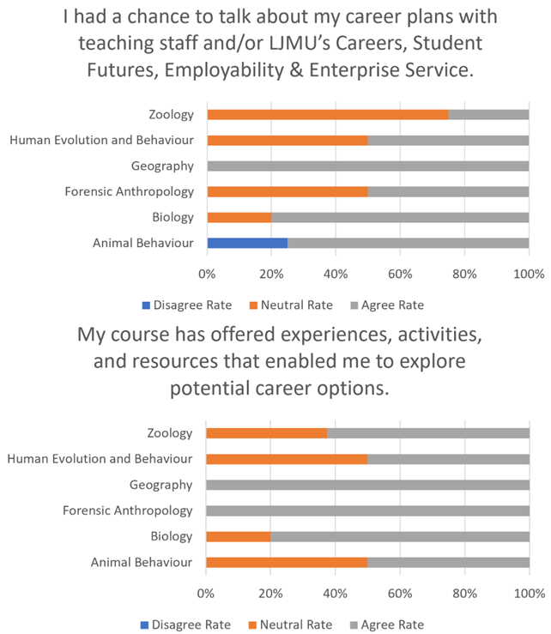
Figure 3: Programme level responses to relevant employability statements from the 2022/23 UKES survey of returning students (L5 only). Respondents are asked to rate their agreement with specific statements.

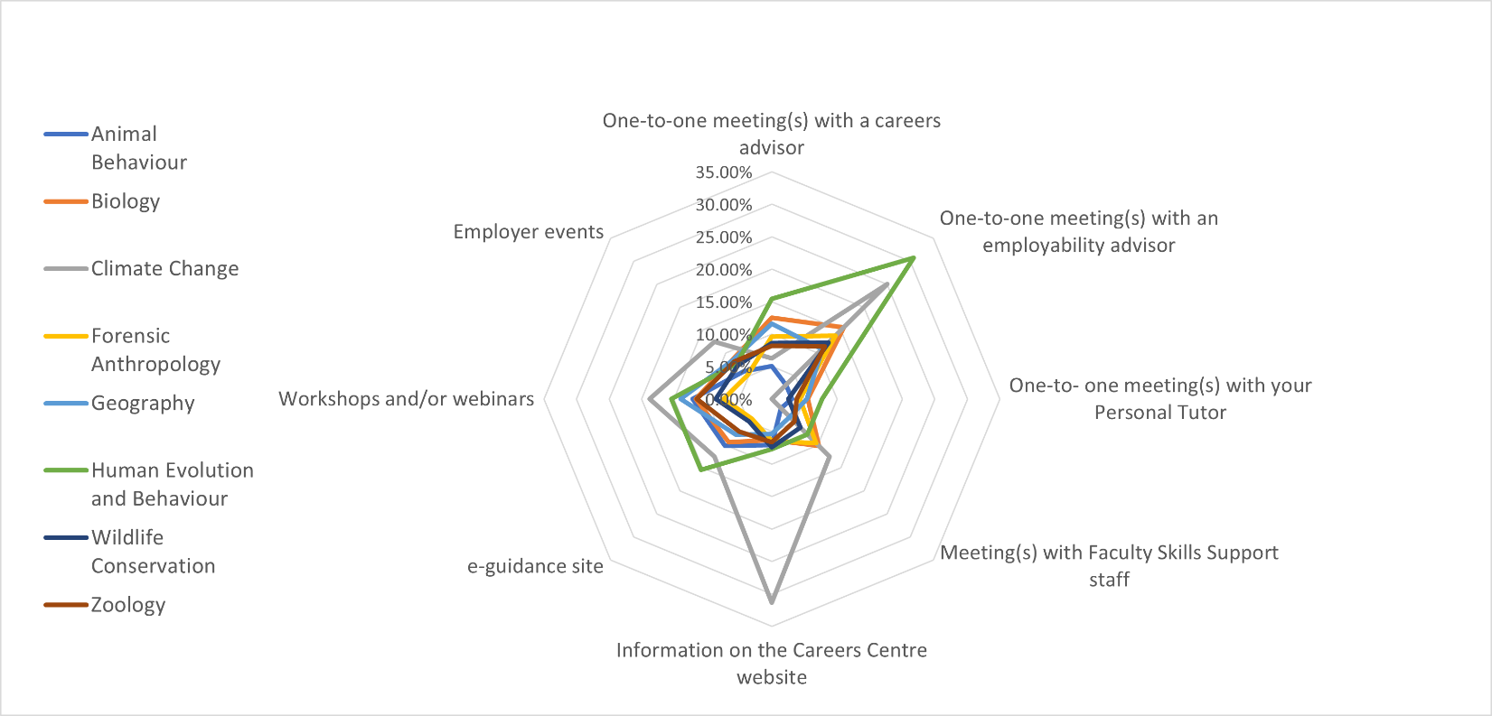
Figure 4: Programme level uptake of Student Futures resources and events by returning students. Data collected as part of the Career Readiness Survey.

Activities
Activities within the school were provided by Student Advancement or within each of the programmes.

Student Advancement Activities
Activities and sessions provided by Student advancement took the form of in-person, online and recorded events, online resources, and 1:1 appointments
- There were several resources and careers fairs provided for the students in Biological and Environmental Sciences
  - There was intervention with the programmes at each level in the form of Future Focus and CareerZone 24/7 Skills Checker
  - Extra-curricular careers events in Climate Change, Forensic Anthropology, Geography, and Wildlife Conservation.
  - In-curricula careers events in the Biosciences module
  - More general activities included: a Biomedical Science, Biochemistry and Biotechnology event (for SCS); Cosmetic Science Industry event (SCS); Careers in Cardiac Science Event (SCS); Sports and Volunteering Careers Fair (for SCS); General Recruitment Fair (all LJMU), and Green Careers Fair (all LJMU), Grad Academy (L6 all LJMU)
  - Students were encouraged by programme teams to engage with CareerZone 24/7 and one-to-one appointments with careers advisors.
  - Laura Aldridge (Student Futures) joined the BES away day to give a talk on career planning.

Placements
A total of 10 students undertook a sandwich year placement between L5 and L6 and 23 students undertook shorter placements during the summer and took the L6 work-based learning module.
- Uptake of placements remains low across the school.
- Sandwich year placement number across the school decreased from 2021-22 during which 13 students took sandwich years.
- The number of students taking shorter placements and the work-based learning module increased from 10 in 2021-22.
- No students from the Environmental Sciences subject area (Geography and Climate Change) took placements in this academic year or last.

Programme | Sandwich Year | Placement Work-Based Learning Module
Animal Behaviour | 4 | 4
Biology |  | 1
Climate Change
Forensic Anthropology |  | 4
Geography
Human Evolution and Behaviour
Wildlife Conservation | 1 | 3
Zoology | 5 | 11
Table 4: Programme level number of enrolments on Sandwich Year Placements and Work-Based Learning module in the 2022-23 academic year.

Programme Activities
Employability activities within programmes occur as a combination of in module skills/activities, tutorials, and provision from the Student Futures team.
- Employability Skills are embedded within each programme at all levels of study
  - Programme teams were surveyed and asked to identify the subject specific and generic employability skills within their programmes and core modules. Generic and subject specific employability skills were taught at all levels in all programmes.
  - Generic skills such as CVs, Cover Letters, Interviews are covered within core modules (usually one per year) and rely on Student Futures and Personal Tutor input. These skills are assessed.
- Within BES, the tutorial system is central to the delivery of programme employability activities.
  - Support, guidance, and assessment on generic employability skills (CVs, Cover Letters, Interviews) in L5 and L6
  - In L6, tutors discussed careers plans with their tutees and identified those without future plans. These students were referred to Student Futures for 1:1 appointments with a careers advisor.
- Future Focus provision
  - Future focus sessions and assessments are provided in all programmes in L4
  - L6 students were encouraged to use the Skills Checker on CareerZone 24/7
- Compulsory in-curricula work-based learning
  - In-curricula work-based learning is in place within the Climate Change, Forensic Anthropology, and Geography programmes
  - Biosciences programmes have identified modules within which the work-based learning can take place and are currently planning implementation.
- Talking About Teaching
  - Within the school, Talking About Teaching took place within programme teams. Animal Behaviour, Biology, Climate Change, Geography, Wildlife Conservation, and Zoology all centred their Talking About Teaching events around Employability.
- BES Away day
  - All programmes took part in an away day on the 28th April during which, the morning session was focussed on discussing employability related matters.
  - Laura Aldridge (Student Futures) joined the BES away day to give a talk on career planning.
  - Programme teams took part in a programme employability survey, CV marking activities, and discussion centred around network building and LinkedIn.
  - Discussions were linked to the BES Employability Action Plan

Ongoing and Future Developments
During the 2022-23 academic year, the institution moved to require all schools with low ‘Progression’ Outcomes as detailed above to produce a careers, employability and enterprise action plan which required identification of school priorities and actions. These priorities and actions were identified and created through consideration of the national and institutional data and in consultation with the school’s academic staff and Student Futures.
- The following priorities were identified:
  - Guarantee that all students leave with a compelling onward plan developed during all levels of their degree.
  - Ensure that students receive top quality employability and careers skill provision from programmes within the school.
  - Provide a wide range of careers events advertising suitable careers and providing career guidance for students within the School of Biological Sciences. These should focus on subject specific employers and those more generic to the skills of biological and environmental scientists such as lab and green careers employers.
  - Ensure that students are aware of both related and alternative options which will utilise the specialised knowledge and the skills which they learn from their degree. Students from all degree subjects can also consider graduate level job options (or schemes) which are open to students from any degree subject within the business, commercial or public sector.
  - Ensure that students from programmes such as Biology and Zoology are aware of scientific graduate scheme options where they can use the specialised knowledge from their degree. For example, there are graduate schemes within the food, health, manufacturing, or pharmaceutical sectors where students can use the scientific specialised skills which they have learnt from their course. (Student Futures can provide information about these opportunities and which employers offer them).
  - Raise awareness amongst students of the different entry points to career paths. Graduate schemes are not the only option. Students may undertake other roles (which could still be classified as professional jobs) which give them experience in a particular career area which can eventually lead to graduate employment – examples could be teaching assistant (for those who want to be a teacher) or therapy assistant (for those who later want to train in healthcare).
  - Provide high quality work-based learning opportunities, both within the curricula, extracurricular, and placements.
  - Enable students to engage with Student Futures resources. Specifically, embed the usage of Careers Zone 24/7 within the curriculum to encourage students to use this resource to develop personally. Assist students in making use of 1-2-1 meetings with Careers and Employability Advisors and sign up to LJMU Connect.
  - Develop enhanced networks of employers and graduates and encourage networking.
- Based on these priorities, the school, its programmes, and Student Futures will take the following actions which will be implemented in the coming academic year:
  - Audit all programmes within the school on their employability and careers provision. This will curriculum mapping to identify modules and assessments linked to the main employability skills (based on post February 2022 PPR/validation documentation), knowledge of graduate destinations and employers, existing networks of employers or knowledge exchange partners, as well as requiring programme teams to identify 4-5 interventions to fill gaps.
  - Inclusion of a mandatory tutorials and sessions in L4 and L5 in which students identify suitable career trajectories and produce development plans (L4) and create a compelling future careers plan (L5)
  - Inclusion of a mandatory sessions in L6 in all programmes for completion of Career Pulse and provide the opportunity to review their future careers plan developed in L5 through the tutorial process.
  - Student Futures provide students with a school wide careers fair focussing on more generic employers of students with biological and environmental sciences skills e.g., lab employers and the green jobs sector.
  - Provide students with subject/programme specific careers events. These events will focus on encouraging past graduates to visit to share their experiences and employers to provide information on subject relevant careers and tips to get jobs. Ensure that students are aware of both related and alternative options which will utilise the specialised knowledge and the skills which they learn from their degree. Students from all degree subjects can also consider graduate level job options (or schemes) which are open to students from any degree subject within the business, commercial or public sector. Raise awareness amongst students of the different entry points to career paths.
  - Develop employer networks alongside Student Futures and create a school employability panel including employers of graduates from the school.
  - Implement core in-curriculum work-based learning opportunities in all programmes within the school. All programmes will meet the university criteria for in-curricula work-based learning tasks.
  - Identify and create placement opportunities. It is envisaged that these will include developing opportunities relevant to students within the school alongside the Student Futures Graduate Futures Project and provision of placements or other work-based learning opportunities for students interested in becoming teachers.
  - Create extracurricular work-based learning opportunity which is linked to employment relevant to any student within the school. This will be competition based.
  - Programmes nominate an employability module in each semester of each level of study which provides a domain for employability focussed events, opportunities, sessions, and tutorials. Programmes will also nominate a specific employability champion to help promote and encourage engagement of programme cohorts with employability and careers provision.
  - Further develop alumni networks both at programme level (using mailing lists and LinkedIn), and through encouraging students to sign up to LJMU Connect alumni network in L6.

Summary
- Overall, Graduate Outcomes (and specifically Progression) in BES is low and a concern given the OfS regulations related to graduate outcomes.
- Low numbers of students receive career advice prior to higher education.
- There is low uptake of the services and resources provided by Student Futures.
- There is low uptake of work-based learning and placements within BES.
- A list of priorities and actions has been created and will be implemented in the coming academic year to address the highlighted issues.

