|  |  |
| --- | --- |
| U:\Logos & signatures\Logos\New LJMU_Master_Logo_Blue CMYK.jpg  Faculty of **Science** | School of Biological and Environmental  Science Employability Coordinator Annual Report 2021/22  Author: J Dick  Date: 31/05/2022 |

# Introduction

Employability and graduate outcomes are becoming increasingly important metrics for student’s choice of institution and there are proposals that these outcomes be used for partitioning of funding of undergraduate programmes.

This report will contextualise the current state of graduate outcomes in BES as well as the current state of the programmes in BES with regard to career readiness. It will also provide an overview of employability activities which have occurred this year and future plans.

# Context

National and institutional data are available to contextualise employability and employment within the School of Biological and Environmental Sciences (BES). These consist of the Graduate Outcome Survey Data from HESA through DiscoverUni.gov.uk and the Career Readiness Survey Data from LJMUs Student Advancement team.

## Office for Students/HESA Data

OfS data for the programmes within Biological and Environmental Sciences included in this report come from NSS and Graduate Outcome Survey (GoS).

* NSS survey data for the three bank questions on employability (Table 1) indicate:
  + BES NSS responses with regard to employability score higher than the sector and LJMU averages. Variance with regard to the sector is greatest with regard to institutional support (Q2), and smallest with regard to preparation for their future careers (Q3).
  + BES programmes fall slightly below the Faculty of Science responses for all questions though only 1-2%. The greatest difference is with regard to institutional support (Q2).

|  |  |  |  |  |  |  |  |  |
| --- | --- | --- | --- | --- | --- | --- | --- | --- |
| **% agree** | **Employability & skills (overall)** | **Variance from sector** | ***Q1*** | **Variance from sector** | ***Q2*** | **Variance from sector** | ***Q3*** | **Variance from sector** |
| Sector | 72 | **-** | 70 | **-** | 64 | **-** | 82 | **-** |
| LJMU | 75 | 3 | 71 | 1 | 70 | 6 | 84 | 2 |
| SCS | 78 | 6 | 72 | 2 | 75 | 11 | 87 | 5 |
| BES | 77 | 5 | 72 | 2 | 73 | 9 | 86 | 4 |

*Table 1: NSS responses to the three bank questions on employability and overall repsonse, indicating the percentage of each programmes cohort that agreed with each statement. The bank question statements are: Q1) My Higher Education experience has helped me plan for my future career; Q2) My institution offered activities and resources designed to prepare me for the next step in my career; Q3) The skills I have developed during my time in Higher Education will be useful for my future career.*

* The results of the first Graduate Outcome Survey for students graduating during the 2018/19 academic year were published in June 2021. This is the second year that the GoS was carried out, having replaced the institutionally administered DHLE survey in 2020.
* There was no access to institutional analysis so data was acquired from HESA and Discover Uni.
  + Percentage of students in employment ranged from 65-95% at 15 months after graduation (Table 2). Compared to the 2017/18 cohorts, several programmes saw decreases in employment of ≥10% (Biology, Forensic Anthropology, and Zoology). Animal Behaviour and Geography saw increases of 10% compared to 2017/18.
  + The percentage of students in highly skilled employment was variable across the school with a range of 20-45%. Biology and Geography showed the highest (45%), and Animal Behaviour the lowest (20%).
  + All programmes in Biological and Environmental Science performed below the LJMU Institutional average (Table 2).
  + The percentage of students in either high skilled employment or further study is likely to be an important metric in the future. Within the school, this percentage ranged 23%-43%.

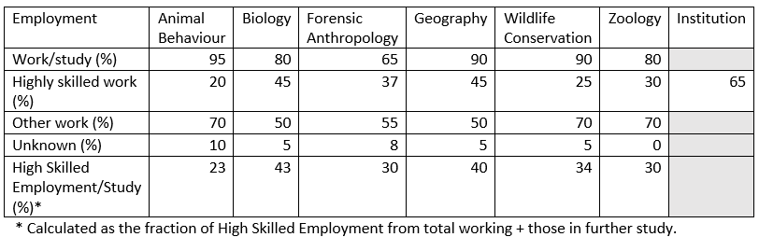

*Table 2: Graduate Outcome Survey employment data 15 months after cessation of study for students graduating in 2018-19. Data shows the total % in work/study, the % in highly skilled employment, and % in other work gathered from DiscoverUni.gov.uk.*

* + As part of the Graduate Outcome Survey, graduates are surveyed on their perceptions of the course with regard to usefulness of knowledge from their degree, the meaningfulness of their work, and whether their work fits with their future plans (Fig. 1).
  + Perceptions of the usefulness of degree knowledge ranged from 35% (Forensic Anthropology and Geography) to 60% (Biology).
  + Perceptions of whether their job fits with their future plans ranged from 35% (Geography) to 75% (Zoology).
  + The low graduate perceptions of degree usefulness and fit with future plans suggests that when aligning course content with careers, greater attention needs to be paid to past graduate destinations though to some degree this could be reflective of more diverse and non-specific careers for some degree programmes (e.g. Geography graduate professional jobs include Project management and marketing professionals).

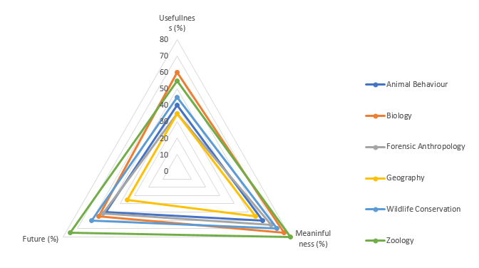

*Fig. 1: BES programme specific responses from the Careers Readiness survey about access to careers advice in the past. This question is provided to new students only.*

## Institutional Data

During the course of a students attendance at LJMU they are surveyed as part of Student Futures administered Career Readiness Survey. Students are surveyed at each level of study on several topics:

* Prior careers advice (Fig. 2)
  + For all programmes in the school of Biological and Environmental Science, only between 22 and 42% of students have had access to career advice prior to joining their programme at LJMU.
  + Career planning and advice from L4 onwards is an important process during their time on their programmes.

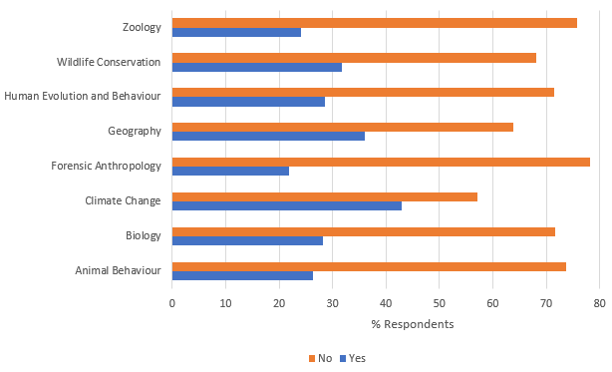

*Fig. 2: BES programme specific responses from the Careers Readiness survey about access to careers advice in the past. This question is provided to new students only.*

* Use of the career service events and facilities (Fig. 3)
  + Students are surveyed on their participation and use of the careers service provision and resources.
  + Across the 7 undergraduate programmes there is very little uptake of careers and employability support
  + Greatest use of support are 1:1 tutorials with personal tutors. However, despite registration of attendance, uptake is still very low (15-35%).
  + Overall, there needs to be an increase in the advertisement of, and encouragement to engage with career development support.
  + Along with this, programmes would benefit from identifying ways to encourage attendance of mandatory 1:1 meetings.

*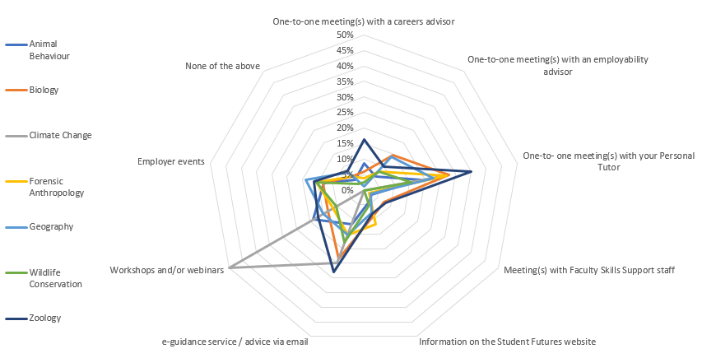*

*Fig. 3: Uptake of careers and employability support from the programmes within BES. Percentages are shown as percentage of cohort, with students able to select multiple options.*

* The status of their career planning and decisions based on a choice of statement within the survey for both new (Fig. 4) and returning students (Fig. 5).
  + The majority of new students in BES chose the statement ‘I have some general career ideas’. This ranged from 50% (Climate Change) to ~80% (Animal Behaviour and Wildlife Conservation) (Fig. 4)
  + 11-36% of new students did not have a career in mind for post-graduation.
  + Returning students showed a slight increase in the percentage who had a career in mind.
  + Data hints at the potential benefits of recent interventions with regard to career planning though only slight increases in students identifying careers suggests more can be done.

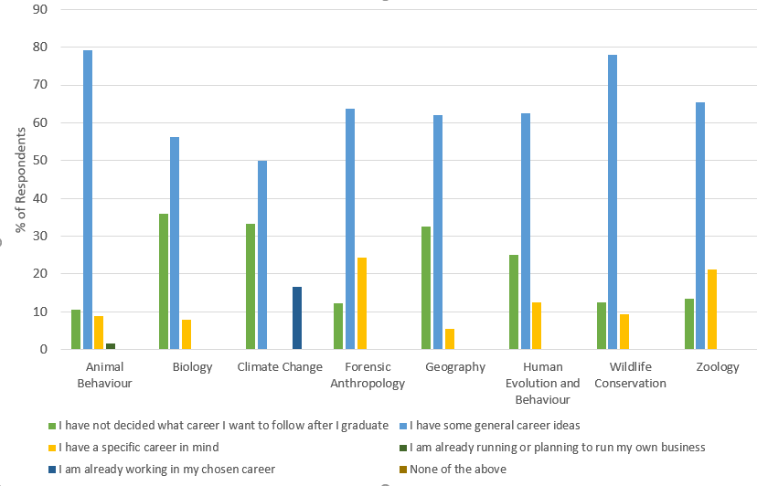

*Fig. 4: Programme specific breakdown of student choice of career readiness statement for new students. Choice of statement is given as % of respondents for each programme.*

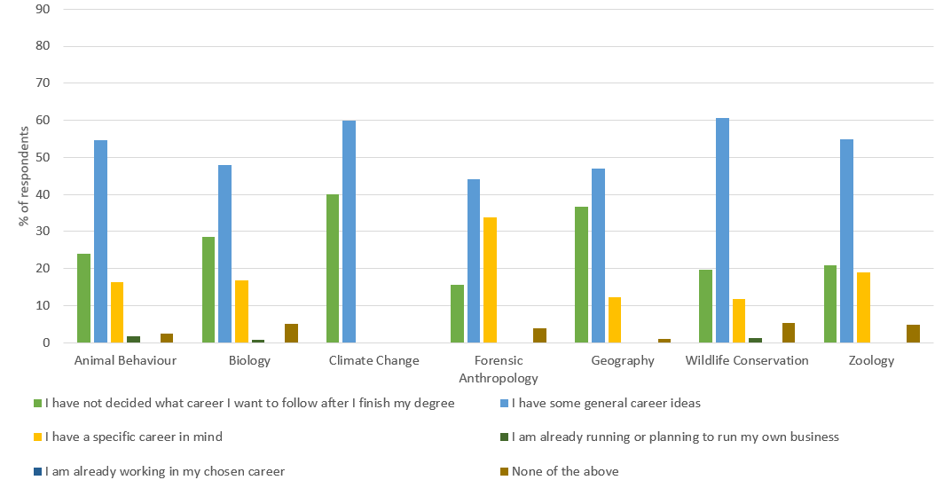

*Fig. 5: Programme specific breakdown of student choice of career readiness statement for returning students. Choice of statement is given as % of respondents for each programme.*

# Activities

Activities within the institution and school were provided by Student Advancement or within each of the programmes.

## Student Advancement Activities

Activities and sessions and support provided by Student advancement took place in the form of in-person, online events, online resources, and 1:1 appointments.

* Use of Careers Zone 24/7 continues to be encouraged and utilised to build employability and careers skills, as well as offer job listings.
* Creation of LJMU Connect to encourage networking between alumni and encourage mentoring of current students
* Specific careers support for students with autism or any social / communication disorder
* There were several webinars and employer events and careers fairs provided for the students within the institution.
  + Employer, careers and skills events. E.g. Maximising LinkedIn for your career, a careers event for those interested in working in micro, small and medium-sized businesses, Graduate & Placement Recruitment Fair.
  + Future Week: A week of talks, career sessions and support designed for L6 students
  + Grad Cafés to help students stay connected and help them with their next steps
  + LJMU Get into Teaching events
* Faculty and school level
  + Activities included: a workshop on applying for graduate level medicine; a working in forensics event, an employer event on working in the cosmetics industry; webinar on the Scientist Training Programme (STP)
* Programme level
  + There was intervention with the programmes in all programmes in L4 through Future Focus
  + Specific programme interventions from the Student Futures team e.g. in the Biosciences module 5201NATSCI.
  + Employer and alumni events for Climate Change, Forensic Anthropology, Geography, and Wildlife Conservation organised by programme teams, Laura Aldridge, and Lisa OFarrel.

# *Placements*

A total of 13 BES students undertook a sandwich year and 10 undertook work-based learning between L5 and L6.

* Numbers are stable compared to academic year 2020-2021.
* Zoology had the largest number of students (5) taking work-based learning, and wildlife Conservation had the largest number of students undertaking a sandwich year this year (7).
* No students from Biology took placements.

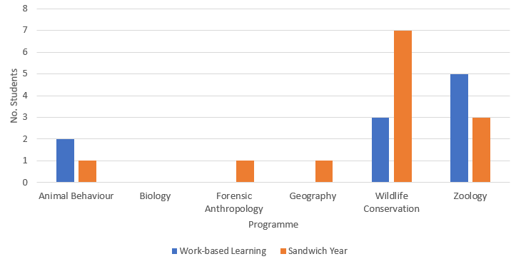

*Fig. 7: Placements for each programme in the School of Biological and Environmental Science for: Work-based learning (summer placement) and the sandwich year. Note: Data given as numbers of students and not percentage of level.*

* Outside of the formal placement opportunities Dr. Richard Webster

## Programme Activities

Current employability activities within programmes occur as a combination of in module skills/activities, tutorials, and provision from the Student Futures Team.

* Employability Skills are embedded within each programme at all levels of study
  + Generic skills such as CVs, Cover Letters, Interviews are covered within core modules (usually one per year) and rely on Student Futures and Personal Tutor input. These skills are assessed.
* Within BES, the tutorial system is central to the delivery of programme employability activities.
  + Support, guidance, and assessment on generic employability skills (CVs, Cover Letters, Interviews) in L5 and L6.
  + In L6, tutors discussed careers plans with their tutees and identified those without future plans. These students were referred to the Careers and Employability Advisors for 1:1 appointments.
* Future Focus
  + Future focus sessions and assessments are provided in all programmes at L4.
* Building a larger alumni network.
  + Programme teams have been active in encouraging graduating students to remain as part of an alumni network. L6 students have been provided with the opportunity to link with programme teams on LinkedIn or join Career Opportunity mailing lists (e.g. Animal Behaviour).
  + Alumni networks will be used as a pool of programme graduates to utilise for careers talks/events.
* Increased advertisement of employment, internship, and placement opportunities.
  + Greater encouragement of take-up of work-based learning opportunities and sandwich years in conjunction with Carlo Meloro and Torsten Wronski.
  + Advertisements for relevant internships and placements to L5 students in conjunction with Student Futures.
  + Advertisement of suitable jobs and graduate schemes to L6 students in conjunction with Student Futures.

## Future Developments

Future developments will see employability interventions by programme teams and further adoption of the institutional and school employability. Further enhanced offerings with regard to Student Futures offerings will also be made.

* As part of the periodic review process, programme teams have amended their programmes to enhance employability and careers content to begin in 2022-2023.
  + Biosciences (Animal Behaviour and have introduced assessed tutorials to encourage greater engagement with group and 1:1 tutorials. They have also introduced an assessed employability portfolio at L5 (5201NATSCI).
  + Environmental Sciences and Forensic Anthropology have mandatory introduced work-based learning opportunities within their core modules lead by industry representatives, something which will be further implemented across the school.
    - Mandatory work-based learning within an Environmental Sciences module (5302NATSCI) began this year, and will be further developed in line with institutional strategy in 2022-2023.
* Programmes will tweak and adapt module content and assessments to emphasis employability skills (already implemented to some extent this year).
  + - * Deeper embedding of, and greater emphasis on employability skills within each programme.
      * Use of novel assessments to build/increase transferable skills capabilities
* Further develop industry connections to increase networks of employers and build a large potential resource for work-based learning opportunities
  + Developed in conjunction with Student Futures.
* Organise more specific programme/subject specific careers events.
  + Organised in conjunction with Student Futures.
* Introduce careers content during induction activities to emphasise the connection between university and student futures
* In the 2023-2022 academic year, a new BSc Environmental Science programme will commence designed to provide students with the knowledge and skillsets to enter the expanding green jobs sector.

## Summary

* Graduate Outcomes and the Career Readiness of students in BES remain low with poor numbers of graduates finding high skilled employment or further study within 15 months of graduation.
* There remains a low uptake of the services and resources provided by Student Futures.
* There is low uptake of work-based learning and placements within BES.
* As part of the recent periodic programme reviews from next academic year (2022-2023), programme amendments will strengthen delivery of skills within the course content, tutorial programme, and encourage increase attendance at 1:1 progress review meetings with personal tutors.
* Work-based learning opportunities outside of the placement system will be increased across the school.