|  |  |
| --- | --- |
| U:\Logos & signatures\Logos\New LJMU_Master_Logo_Blue CMYK.jpg  Faculty of **Science** | School of Biological and Environmental  Science Employability Coordinator Annual Report 2020/21  Author: J Dick  Date: 07/06/2021 |

# Introduction

Employability and graduate outcomes are becoming increasingly important metrics for student’s choice of institution and there are proposals that these outcomes be used for partitioning of funding of undergraduate programmes.

This report will contextualise the current state of graduate outcomes in BES as well as the current state of the programmes in BES with regard to career readiness. It will also provide an overview of employability activities which have occurred this year and future plans.

# Context

National and institutional data are available to contextualise employability and employment within the School of Biological and Environmental Sciences (BES). These consist of the NSS and Graduate Outcome Survey Data from the Office for Students (OfS) and Career Readiness Survey Data from LJMUs Student Advancement team.

## Office for Students Data

OfS data for the programmes within Biological and Environmental Sciences included in this report come from the National Student Survey and Graduate Outcome Survey.

* NSS survey data for the three bank questions on employability (Fig. 1) indicate:
  + The school average for Q1 indicates an overall 77% of students agreed with the statement. The range was 55% linked to the poor agreement in Forensic Anthropology and high agreement in Wildlife Conservation.
  + Q2 links to institutional activities and career preparation. Agreement across the school averaged 86% with a range from 76% to 91%.
  + Overall, 86% of students in the school agreed that the skills developed would be useful in their future career (Q3). The range in agreement was 45%, again linked to poor agreement from Forensic Anthropology respondents.



40

50

60

70

80

90

100

Animal

Behaviour

Biology

Forensic

Anthropology

Geography

Wildlife

Conservation

Zoology

*% Respondents Agree*

*Undergraduate Programme*



Q1



Q2

Q3

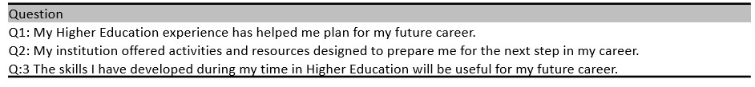

*Fig 1: NSS responses to the three bank questions on employability, indicating the percentage of each programmes cohort that agreed with each statement. The bank question statements are provided in the table below the bar chart.*

* The results of the first Graduate Outcome Survey for students graduating in 2018 were published in June 2020 which replacing the institutionally administered DHLE survey.
  + Percentage of students in employment ranged from 80-90% (Table 1)
  + The percentage of students in highly skilled employment was variable across the school with only Biology exceeding 50%. The majority of programmes were 30% or less. (Table 1).
  + All programmes in Biological and Environmental Science performed below the LJMU average, with only 2 programmes within 10% of it (Table 2)
  + This signals the requirement for intervention as the percentage of students in highly skilled employment is likely to be in important metric going forwards.

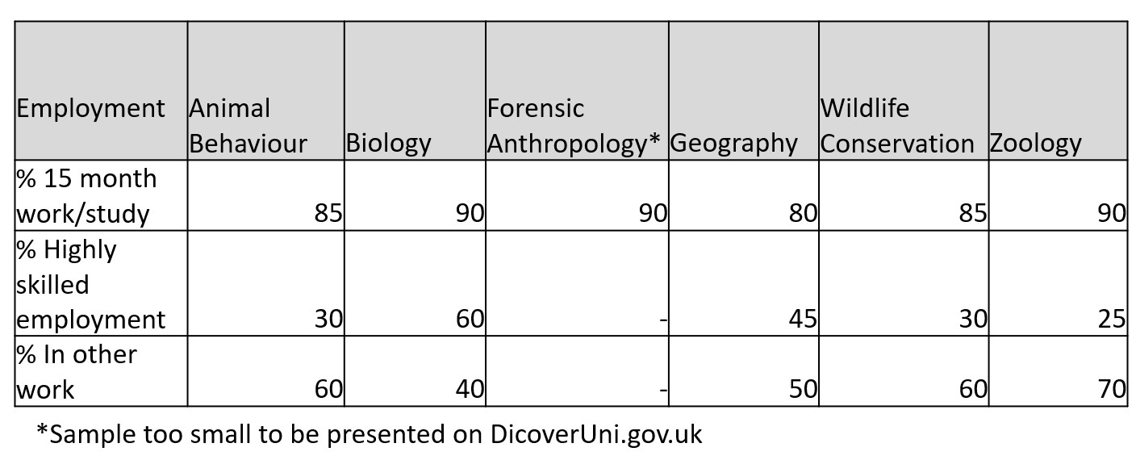

*Table 1: Graduate Outcome Survey employment data 15 months after cessation of study for students graduating in 2017-18. Data shows the total % in work/study, the % in highly skilled employment, and % in other work gathered from DiscoverUni.gov.uk.*

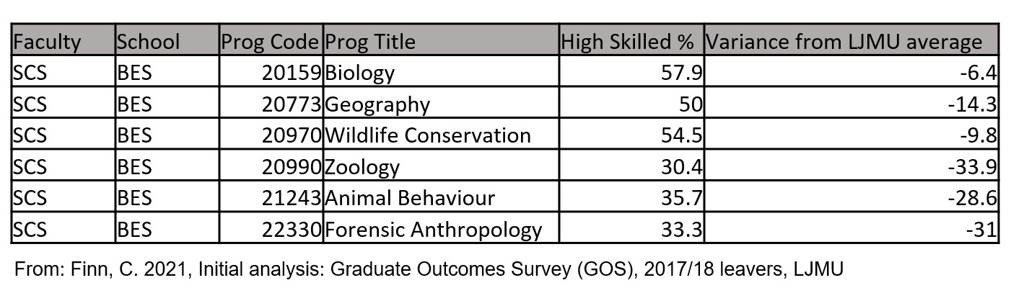

*Table 2: Graduate Outcome Survey high skilled employment data 15 months after cessation of study for students graduating in 2017-18. Data shows the % in highly skilled employment, and variance from the LJMU average.*

## Institutional Data

During the course of a students attendance at LJMU they are surveyed as part of Student Advancement administered Career Readiness Survey. Students are surveyed at each level of study on several topics:

* Prior careers advice (Fig. 2)
  + For all programmes in the school of Biological and Environmental Science, only between 20 and 40% of students have had access to career advice prior to joining their programme at LJMU.
  + Career planning from L4 onwards is an important process during their time on the programme.

0

10

20

30

40

50

60

70

80

90

100

Yes

No

% of respondents

Have new L4 students had careers advice in the past?

Animal Behaviour

Biology

Climate Change

Forensic Anthropology

Geography

Wildlife Conservation

Zoology

*Fig. 2: BES programme specific responses from the Careers Readiness survey about access to careers advice in the past. This question is provided to new students only.*

* Use of the career service events and facilities (Fig. 3)
  + Students are surveyed on their participation and use of the careers service provision and resources.
  + On average across the 7 undergraduate programmes, 44% are not making use. Lack of use of the services and resources ranges from 33% (Wildlife Conservation) to 52% (Biology).

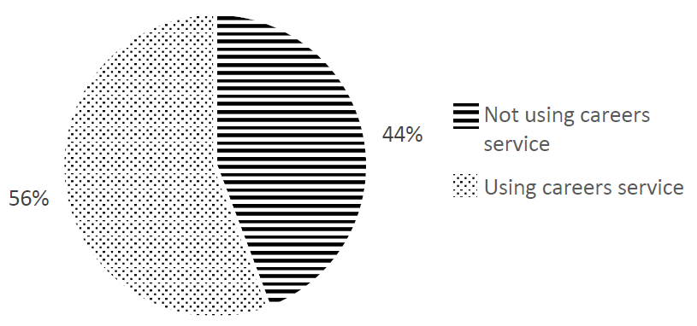

*Fig. 3: BES breakdown of students who have not used resources provided by the careers service or attended events in the past year. Students who spoke to their personal tutor about careers only, included in the section for having not used the service.*

* The status of their career planning and decisions based on a choice of statement within the survey.
  + The majority of new students in BES chose the statement ‘I have some general career ideas’. This ranged from ~50% (Forensic Anthropology) to >80% (Climate Change) (Fig. 4)
  + Returning students showed a similar pattern to new students in terms of statements 1, 2, and 3. (Fig. 5)
  + ~5-10% of students for all programmes chose the statement ‘I wish to gain experience / travel / before applying for jobs’
  + In general, students taking postgraduate courses were less likely to have chosen statement 1 (Not decided on a career) (Fig. 4)

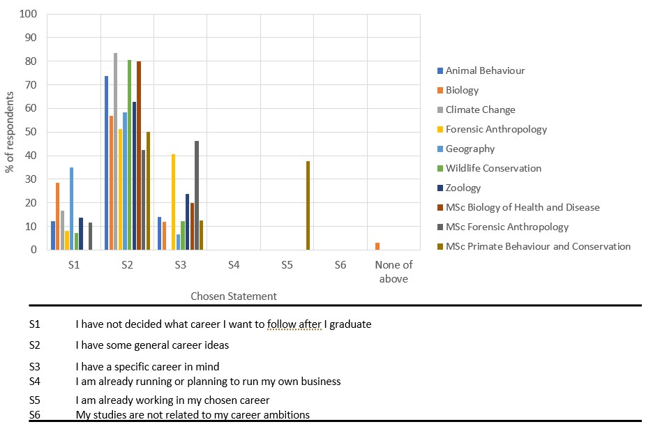

*Fig. 4: Programme specific breakdown of student choice of career readiness statement for new students. Choice of statement is given as % of respondents for each programme. Statements are provided in the table below the graph.*

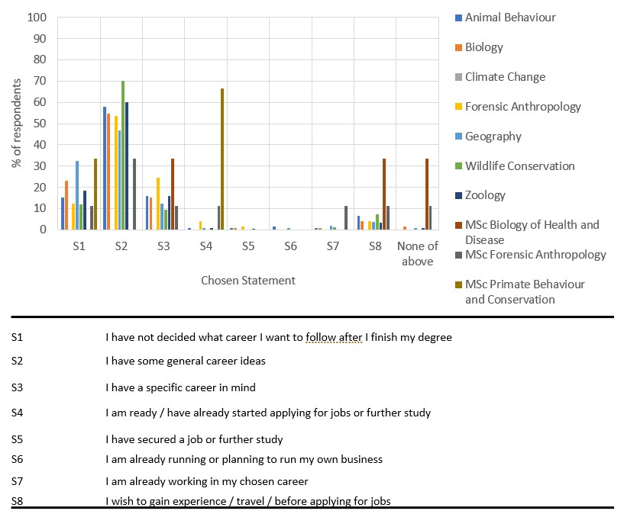

*Fig. 5: Programme specific breakdown of student choice of career readiness statement for returning students. Choice of statement is given as % of respondents for each programme. Statements are provided in the table below the graph.*

# Activities

Activities within the school were provided by Student Advancement or within each of the programmes.

## Student Advancement Activities

Activities and sessions provided by Student advancement took the form of online and recorded events, online resources, and 1:1 appointments

* There were several webinars and virtual careers fairs provided for the students in Biological and Environmental Sciences
  + 20 alumni from BES were interviewed to create videos for use at the careers events for each programme
  + There was intervention with the programmes at each level in the form of Future Focus and Career Pulse
  + A careers talk by Ardent Land Management was provided for the Geography Programme. 6 students attended – 2 of which then secured jobs with Ardent.
  + More general activities included: a National School of Healthcare-The Scientist Training Programme (for SCS); Sports and Volunteering Careers Fair (for SCS); General Recruitment Fair (all LJMU)

* As an immediate intervention with regard to the Graduate Outcome Survey data, a week of enhanced employability provision was organised in week 32. This week was provided to L6 students only:
  + Two subject specific webinars were provided during the week from the BES Careers Advisor Hayley Fallon
  + 1:1 appointments with Careers and Employability Advisors were ring-fenced for BES students only. There was also a scheme to reward the first students attending the 1:1 appointments.
  + Forensic Anthropology provided a programme specific employability event from their perspective. This was provided by Julie Roberts and David Jordan
  + Engagement was poor, with generally single figures for each offering.

* 1:1 appointments are available with Careers and Employability advisors for students at all levels and graduates.
  + Uptake of 1:1 appointments was greatest in semester 1 (Fig 6a) o
  + Overall, there was greater uptake of 1:1 appointments with Employability advisors (dealing with CVs, applications, etc.) (Fig 6)
  + The total number of 1:1 appointments from BES students is lowest in the faculty.

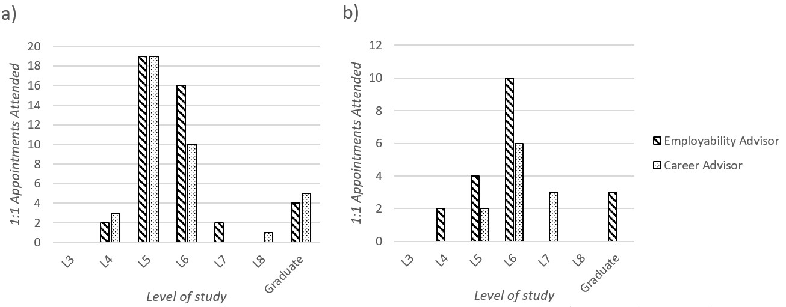

*Fig. 6: The number of 1:1 appointments per level of study for students in the School of Biological and Environmental Sciences. Data shows appointments with both Employability Advisors and Career Advisors for: a) semester 1; b) semester 2.*

# *Placements*

A total of 13 BES students undertook a sandwich year and 10 work-based learning between L5 and L6.

* Numbers are lower than previous years due to the pandemic
* Animal behaviour had the largest number of students undertaking placements this year.
* No students from geography took placements.

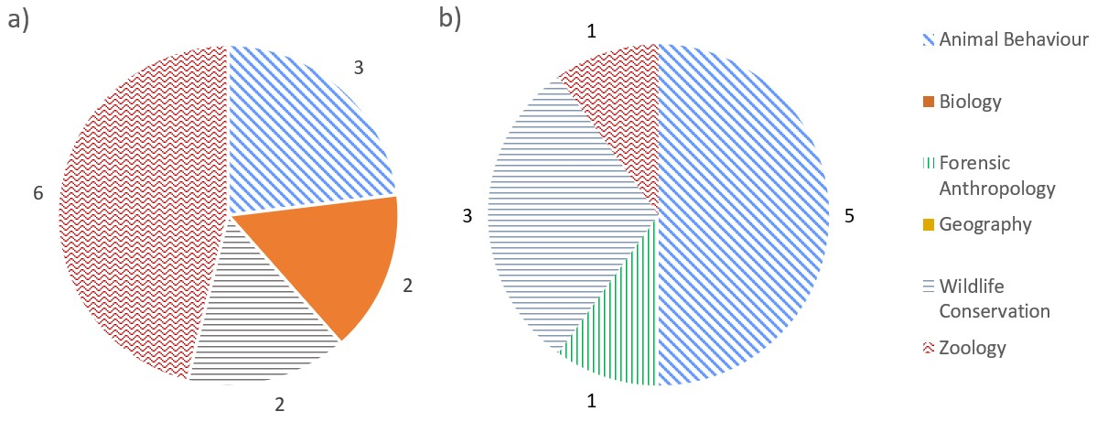

*Fig. 7: Virtual or in-situ placements for each of the School of Biological and Environmental Science for: a) Sandwich year; b) Work-based learning. Data labels indicate the actual number of students for each programme.*

## Programme Activities

Employability activities within programmes occur as a combination of in module skills/activities, tutorials, and provision from the Student Advancement Team.

* Employability Skills are embedded within each programme
  + Programme teams were surveyed and asked to identify the subject specific and generic employability skills within their programmes and core modules. Generic and subject specific employability skills were taught at all levels in all programmes.
  + Generic skills such as CVs, Cover Letters, Interviews are covered within core modules (usually one per year) and rely on Student Advancement and Personal Tutor input. These skills are assessed.
* Within BES, the tutorial system is central to the delivery of programme employability activities.
  + Support, guidance, and assessment on generic employability skills (CVs, Cover Letters, Interviews) in L5 and L6
  + In L6, tutors discussed careers plans with their tutees and identified those without future plans. These students were referred to the Careers Service for 1:1 appointments with a careers advisor. Unfortunately, despite large numbers of referrals, uptake was poor.
* Future Focus and Career Pulse provision
  + Future focus sessions and assessments are provided in all programmes at L4 and L5
  + Career Pulse was provided to all L6 students within the Dissertation/Project module for each programme

## Future Developments

Future developments will see employability interventions by programme teams and the creation of an employability strategy for the school which will be aligned with the university strategy. Further enhanced offerings with regard to student advancement offerings will also be made.

* Programmes will be designing interventions to address the Graduate Outcome Survey data
  + Deeper embedding of, and greater emphasis on employability skills within each programme through the tutorial programme and assessment. From the moment a student joins a BES they should be thinking of their employability.
    - * L4 tutorial interventions will begin 2021-2022 and focus on career planning
      * Programme teams will identify scope for employability themed assessments and module amendments required
  + Industrial and employer connections will be fostered to build a body of relevant employers for programme development and employability activities.
  + Programmes should encourage greater uptake of work-based learning and placements. Programmes will also need to identify areas where employability skills, and work-based learning opportunities can be built into the curriculum through assessment.

* Greater programme collaboration with Student Advancement to:
  + - Enhance our offering of general and subject specific careers talks and activities
    - Promote the use of Careers Zone 24/7
    - Encourage uptake of appointments with Careers and Employability advisors

* Another week of an enhanced offering of 1:1 appointments and subject specific events for BES L6 students will take place 2021-2022. It is envisaged that this will take place in semester 1.

## Summary

* Overall, Graduate Outcomes and the Career Readiness of students in BES is low.
* There is low uptake of the services and resources provided by Student Advancement
* There is low uptake of work-based learning and placements within BES
* Interventions are being undertaken to greatly strengthen the student perception and programme delivery of the importance of employment and employability skills by:
  + Emphasizing the need to use the Career Service
  + Increasing the embedding of employability skills and career planning in each programme
  + Attempting to foster relations with employers
  + Providing further careers and employability events for students