**Accessibility – Changing the background colour.**

## In Word

To change the background colour, go to the page layout tab. In the page background option select Page Color then choose and appropriate colour.

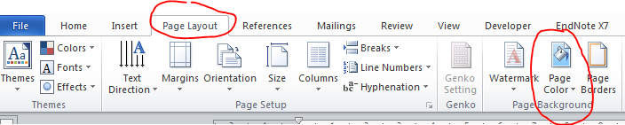

## In a pdf

Go to Edit > Preferences > Accessibility choose the appropriate colour by clicking on the page background box.

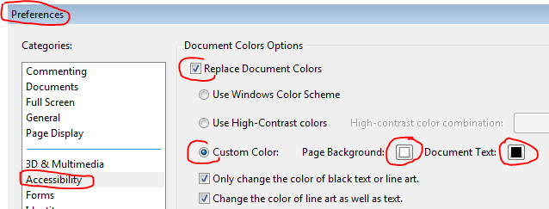

## In Blackboard

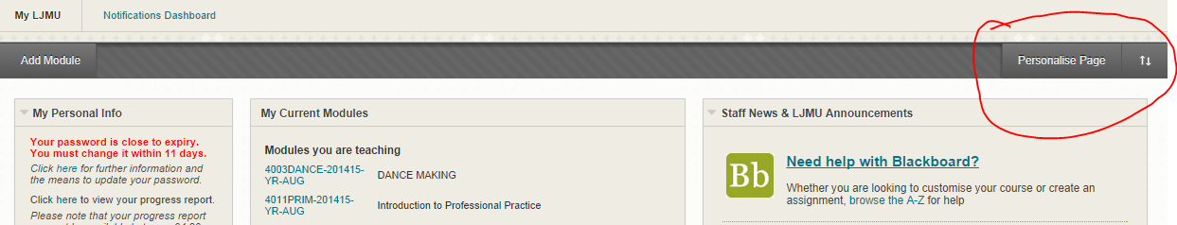Choose colours to suit.

## In Outlook

When writing an email message, click on the Options tab, then Page Color, and select an appropriate colour. Note: You need some text in the message before you can change the background colour.

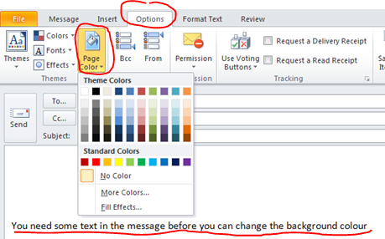

**Thanks to Ruth Nagus, Oct 2014**